# Task 02 Day 05

**Team Members:** Rashmi Singh, Ankit Soni, Vishesh Chhaperwal, Amrutha Varshini, Mohan Satwik, Azmeera thrupathi

## Verilog Code for 4x1 Mux:

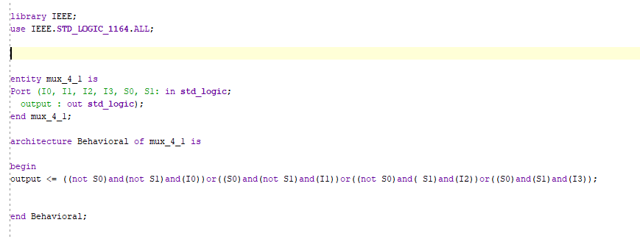

**Test Bench:**

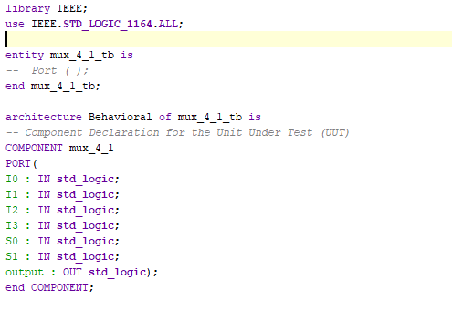

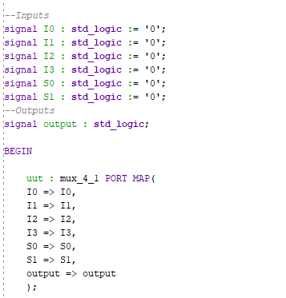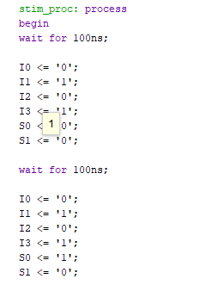

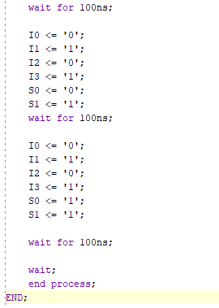

**Schematic Diagram:**

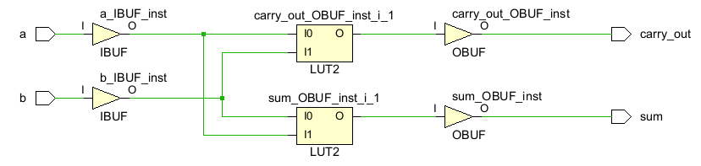

**Design Timing Summary:**

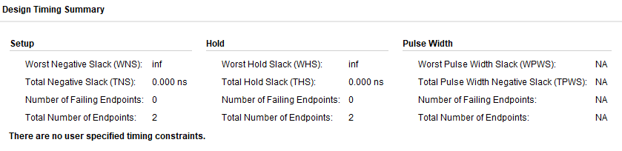

**Device:**

